

QUIZ APPLICATION

A PROJECT REPORT
Submitted by

DHARANISH S (8115U13AM017)

in partial fulfillment of requirements for the award of the course
CGB1201 - JAVA PROGRAMMING
In
DEPARTMENT OF
COMPUTER SCIENCE AND ENGINEERING
(ARTIFICIAL INTELLIGENCE AND MACHINE LEARNING)

K. RAMAKRISHNAN COLLEGE OF ENGINEERING
(An Autonomous Institution, affiliated to Anna University Chennai and Approved by AICTE ,New Delhi)

SAMAYAPURAM–621112

DECEMBER - 2024

K.RAMAKRISHNANCOLLEGEOFENGINEERING
(AUTONOMOUS)
SAMAYAPURAM–621112

BONAFIDE CERTIFICATE

Certified that this project report on “QUIZ APPLICATION” is the bonafide work of S.DHARANISH(8115U23AM017)who carried out the project work during the academic year 2024 - 2025 under my supervision.

SIGNATURE | SIGNATURE
Dr.B.KIRANBALA,B.Tech.,M.E.,M.B.A.,Ph.D.,M.I.S.T.E., U.A.C.E.E., IAENG | Mr. P.GEETHA,M.E
HEAD OF THE DEPARTMENT, | ASSISTANT PROFESSOR,
Department of Artificial Intelligence and Machine Learning, | Department of Artificial Intelligence and Data Science,
K. Ramakrishnan College of  Engineering, | K. Ramakrishnan College of  Engineering,
Samayapuram, Trichy-621 112. | Samayapuram, Trichy-621 112.  .

Submitted for the End Semester Examination held on…………….

INTERNAL EXAMINER EXTERNAL EXAMINER

DECLARATION

I declare that the project report on “QUIZ APPLICATION” is the result of original work done by me and best of our knowledge, similar work has not been submitted to “ANNA UNIVERSITY CHENNAI” for the requirement of Degree of BACHELOR OF ENGINEERING. This project reportis submitted on the partial fulfillment of the requirement of the award of the cours CGB1201-JAVA PROGRAMMING

Signature
DHARANISH S

ACKNOWLEDGEMENT

It is with great pride that I express our gratitude and in debtedness to our institution, “K.RAMAKRISHNAN COLLEGE OF ENGINEERING
(Autonomous)”,for providing me with the opportunity to do this project. I extend our sincere acknowledgment and appreciation to the esteemed and honorable Chairman, Dr. K. RAMAKRISHNAN, B.E., for having provided the facilities during the course of our study in college.

I would like to express our sincere thanks to our beloved Executive Director , Dr.S. KUPPUSAMY, MBA, Ph.D., for forwarding our project and offering an adequate duration to complete it.I would like to thank Dr. D. SRINIVASAN, M.E., Ph.D., FIE., MIIW.,MISTE., MISAE., C. Engg., Principal, who gave the opportunity to frame the project to full satisfaction.

Dr. B. KIRAN BALA, B.Tech., M.E., M.B.A., Ph.D., M.I.S.T.E.,
U.A.C.E.E., IAENG, Head of the Department of Artificial Intelligence and Machine Learning, for providing his encouragement in pursuing this project.

I wish to convey our profound and heartfelt gratitude to our esteemed project guideMrs. P.GEETHA, M.E., Department of Artificial Intelligence and Data Science, for her incalculable suggestions, creativity, assistance and patience, which motivated us to carry out this project.

I render our sincere thanks to the Course Coordinator and other staff members for providing valuable information during the course.

I wish to express our special thanks to the officials and Lab Technicians of our departments who rendered their help during the period of the work .

INSTITUTE VISION AND MISSION

VISION OF THE INSTITUTE:
To achieve a prominent position among the top technical institutions.

MISSION OF THE INSTIITUTE:
M1: To be show standard technical education excellence through state of the art infrastructure, competent faculty and high ethical standards.
M2: To nurture research and entrepreneurial skills among students in cutting edge technologies.
M3: To provide education for developing high-quality professionals to transform the society.

DEPARTMENT VISION AND MISSION

DEPARTMENT OF CSE(ARTIFICIAL INTELLIGENCE AND MACHINE LEARNING)

Vision of the Department
To become a renowned hub for Artificial Intelligence and Machine Learning
Technologies to produce highly talented globally recognizable technocrats to meet
Industrial needs and societal expectations.

Mission of the Department
M1: To impart advanced education in Artificial Intelligence and Machine Learning,
Built upon a foundation in Computer Science and Engineering.
M2: To foster Experiential learning equips students with engineering skills to Tackle real-world problems.
M3: To promote collaborative innovation in Artificial Intelligence, machine
Learning, and related research and development with industries.
M4: To provide an enjoyable environment for pursuing excellence while upholding
Strong personal and professional values and ethics.

Programme Educational Objectives (PEOs):
Graduates will be able to:
PEO1: Excel in technical abilities to build intelligent systems in the fields of Artificial Intelligence and Machine Learning in order to find new opportunities.
PEO2: Embrace new technology to solve real-world problems, whether alone or
As a team, while prioritizing ethics and societal benefits.
PEO3: Accept lifelong learning to expand future opportunities in research and Product development.

Programme Specific Outcomes (PSOs):
PSO1: Ability to create and use Artificial Intelligence and Machine Learning Algorithms, including supervised and unsupervised learning, reinforcement Learning, and deep learning models.
PSO2: Ability to collect, pre-process, and analyze large datasets, including data Cleaning, feature engineering, and data visualization..

PROGRAM OUTCOMES(POs)
Engineering students will be able to:

- Engineering knowledge: Apply the knowledge of mathematics, science, engineering fundamentals, and an engineering specialization to the solution of complex engineering problems.
- Problemanalysis:Identify,formulate,reviewresearchliterature,andan
alyze complex engineering problems reaching substantiated conclusions using first principles of mathematics, natural sciences, and engineering sciences
- Design/development of solutions: Design solutions for complex engineering problems and design system components or processes that meet the specified needs with appropriate consideration for the public health and safety, and the cultural, societal, and environmental considerations

- Conduct investigations of complex problems: Use research-based knowledge and research methods including design of experiments, analysis and interpretation of data, and synthesis of the information to provide valid conclusions
- Modern tool usage: Create, select, and apply appropriate techniques, resources, and modern engineering and IT tools including prediction and modeling to complex engineering activities with an understanding of the limitations
- The engineer and society: Apply reasoning informed by the contextual knowledge to assess societal, health, safety, legal and cultural issues and the consequent responsibilities relevant to the professional engineering practice

- Environment and sustainability: Understand the impact of the professional engineering solutions in societal and environmental contexts, and demonstrate the knowledge of, and need for sustainable development
- Ethics: Apply ethical principles and commit to professional ethics and responsibilities and norms of the engineering practice.
- Individual and team work: Function effectively as an individual, and as a member or leader in diverse teams, and in multidisciplinary settings.
- Communication: Communicate effectivelyon complex engineering activities with the engineering community and with society at large, such as, being able to comprehend and write effective reports and design documentation, make effective presentations, and give and receive clear instructions.
- Project management and finance: Demonstrate knowledge and understanding of the engineering and management principles and apply these to one’s own work, as a member and leader in a team, to manage projects and in multidisciplinary environments.
- Life-long learning: Recognize the need for, and have the preparation and ability to engage in independent and life-long learning in the broadest context of technological change.

ABSTRACT

The application is an interactive platform designed for users to take quizzes on various topics, offering a personalized and engaging experience. Upon launching, users are prompted to provide their name, roll number, and email, ensuring a tailored interaction. The interface dynamically displays questions and their options within a scrollable layout, enabling seamless navigation through multiple questions. Users select answers via radio buttons, with their choices stored in a Hash Map for evaluation. After completing the quiz, the application calculates the user's score by comparing their responses with predefined correct answers and presents the result alongside their entered details. The design is modular, featuring a reusable and extensible Question class that encapsulates attributes such as ID, text, and options, ensuring maintainability and scalability.

ABSTRACT WITH POs AND PSOs MAPPING

ABSTRACT | POs  MAPPED | PSOs  MAPPED
The application is an interactive quiz platform where users input their name, roll number, and email for a personalized experience.  It features a dynamic, scrollable interface for navigating questions, with answers stored in a Hash Map for evaluation.  After the quiz, the score is calculated by comparing responses to correct answers and displayed with user details. A modular Question class ensures scalability and maintainability. | PO1 -3  PO2 -3  PO3 -3  PO4 -3  PO5 -3  PO6 -3  PO7 -3  PO8 -3  PO9 -3  PO10 -3  PO11-3  PO12 -3 | PSO1 -3  PSO2 -3
Note: 1- Low, 2-Medium, 3- High

TABLE OF CONTENTS

CHAPTER  No. | TITLE | PAGE  No.
 | ABSTRACT | ix
1 | INTRODUCTION | 1
 | 1.1 Objective | 1
 | 1.2 Overview | 1
 | 1.3 Java Programming concepts | 2
2 | PROJECT METHODOLOGY | 5
 | 2.1Proposed Work | 5
 | 2.2 Block Diagram | 8
3 | MODULE DESCRIPTION | 9
 | 3.1 User Details Module | 9
 | 3.2 Quiz Initialization Module | 9
 | 3.3 Question Display Module | 9
 | 3.4 Answer Tracking Module | 9
 | 3.5 Score Calculation and Feedback Module | 10
4 | CONCLUSION & FUTURE SCOPE | 14
 | 4.1 conclusion
 | 4.2 Future scope
 | APPENDIX-SOURCE CODE | 13
 | APPENDIX-SCREENSHOT | 21
 | REFERENCES | 24

CHAPTER 1 INTRODUCTION

Objective:

    - To provide a platform for users to answer multiple-choice questions.
    - To evaluate users' knowledge and calculate their scores.
    - To offer instant feedback based on the user's performance.
    - To create a user-friendly and interactive interface.
    - To ensure personalization by collecting user details like name, roll number, and email

Overview:
The Quiz Application is a desktop-based program developed in Java using the Swing framework. It is designed to conduct quizzes by presenting users with multiple-choice questions and calculating their scores based on the correctness of their answers. The application begins by collecting the user's details, including name, roll number, and email, to personalize the experience. It dynamically displays a list of questions with answer options, allows users to select their responses, and tracks these answers. Once the quiz is submitted, the application evaluates the responses, calculates the score, and displays the results along with the user's information. This modular and user-friendly application is ideal for educational, training, or self-assessment purposes.

Java Programming Concepts:

Object-Oriented Programming (OOP)
      - Encapsulation:
        - The Question class encapsulates data related to a question (ID, text, and options).
        - Getter methods are used to access the data, ensuring controlled access.
      - Inheritance:
        - The application extends JFrame, inheriting its properties and methods to create a GUI window.
      - Abstraction:
        - Details of how user input is handled and scored are abstracted behind GUI components and internal logic.

Classes and Objects
      - The program uses multiple classes (QuizApplication, Question) to represent different components.
      - Instances of the Question class represent individual quiz questions.

Swing Framework
      - Used for creating a graphical user interface:
        - JFrame: Represents the main application window.
        - JPanel, JScrollPane: Used for organizing and displaying questions.
        - JLabel, JButton, JRadioButton: Display questions, accept user input, and handle user actions.
        - JOptionPane: Displays dialogs for user details and feedback.

Event Handling
      - ActionListeners are attached to buttons (submitButton) and radio buttons to handle user interactions:
        - Submitting the quiz.
        - Capturing user-selected answers.

Collections Framework
      - List:
        - Used to store multiple-choice options for each question (List<String> in the Question class).
        - Used to store all questions (List<Question> in the initializeQuestions method).
      - Map:
        - HashMap<Integer, Integer> stores user responses (userAnswers), where the key is the question ID, and the value is the selected option index.
        - Another HashMap<Integer, Integer> holds the correct answers for score calculation.

Exception Handling
      - The program uses validation to ensure user input is valid (e.g., fields not left blank). Errors are reported using JOptionPane.

Java GUI Layouts
      - Different layouts (GridLayout, BoxLayout, BorderLayout) organize GUI components effectively:
        - GridLayout: Arranges labels and input fields for user details.
        - BoxLayout: Vertically stacks question components in the quiz panel.
        - BorderLayout: Separates main areas for content and buttons.

Static Keyword
      - main() is a static method, serving as the entry point of the application.

Constructors
      - The QuizApplication constructor initializes the application, setting up the GUI and calling supporting methods.

Loops
- A for loop iterates through the questions to dynamically generate GUI components for each question and its options.

Modularity
      - The program separates concerns into different methods (showUserDetailsDialog, initializeQuestions, displayQuestions, etc.), improving code readability and maintainability.

Reusability
      - The Question class can be reused to create quizzes with different content by changing the questions and options.

Java Virtual Machine (JVM) Features
      - Automatic memory management (e.g., objects for GUI components and user input).
      - Platform independence through bytecode execution.

CHAPTER 2 PROJECT METHODOLOGY

Proposed Work:
The proposed Quiz Application aims to provide a user-friendly platform for conducting quizzes through a graphical user interface (GUI). The application will focus on presenting a series of multiple-choice questions to users, capturing their answers, and calculating their final score. Below are the key steps involved in the development and functionality of the proposed work:

User Details Collection
The application will begin by prompting users to enter their personal details, including:
      - Name
      - Roll Number
      - Email
This information will be used to personalize the quiz experience and present results along with the user's details. The input fields will be validated to ensure that all required fields are filled before proceeding.

Quiz Initialization
Once the user’s details are captured, the application will initialize the quiz section. The following features will be included:
      - A dynamic question display interface, which will show one question at a time.
      - Each question will come with four options, where users can select one.
      - The quiz interface will include a submit button to finalize answers.

Question Management
The quiz will consist of multiple-choice questions stored in the application. For each question:
      - The question and associated options will be displayed.
      - The user will be able to select one option per question.
Questions will be hardcoded initially, but the design will be flexible enough to allow easy expansion, such as adding more questions or integrating a database for dynamic question loading.

Answer Tracking
The user's responses will be tracked in real-time as they select their answers. The application will store these responses in a map, where each question is associated with the selected answer. This will help in evaluating the user's performance at the end of the quiz.

Score Calculation
At the end of the quiz, the application will:
      - Compare the user's answers with the correct answers (predefined).
      - Calculate the user's score by counting the correct answers.
      - Display the score along with the user's details (name, roll number, and email). The score calculation will be done programmatically, and feedback will be displayed to the user via a dialog box.

User Interface
The user interface will be built using Java Swing and will include:
      - A main window to house the quiz questions and options.
      - A scrollable panel to ensure that if there are many questions, the user can scroll through them.
      - Buttons (e.g., submit) for user interaction.
      - Dialogs for displaying results and collecting user details.
The layout will be designed to be clean and intuitive, ensuring a seamless experience for the user.

Modular Design
The entire application will be divided into distinct modules to separate concerns and enhance maintainability:
      - User Details Module: Collects and validates user information.
      - Quiz Initialization Module: Initializes and sets up the quiz interface.
      - Question Display Module: Displays questions and captures user selections.
      - Answer Tracking Module: Keeps track of the answers selected by the user.
      - Score Calculation and Feedback Module: Calculates the score and displays feedback to the user.
Each of these modules will work independently and communicate with each other to deliver the final result.

Block Diagram

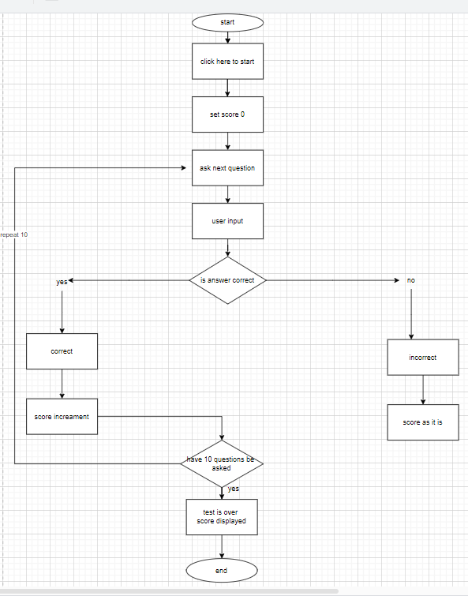

CHAPTER 3 MODULE DESCRIPTION

User Details Module

This module collects the user's personal information, including their name, roll number, and email address. It validates the entered details to ensure completeness and correctness. If any field is empty or invalid, the user is prompted to re-enter the information.

Quiz Initialization Module

This module prepares the quiz environment. It initializes the graphical interface elements, such as panels and buttons, and organizes them to display the quiz in an intuitive layout. It also sets up the scrollable panel to accommodate multiple questions.

Question Display Module

This module is responsible for displaying the quiz questions and their associated multiple-choice options. It dynamically creates and arranges GUI components like labels and radio buttons for each question and organizes them into a user-friendly interface.

Answer Tracking Module

This module tracks the user’s answers for each question in real time. It uses a map to associate question IDs with the user’s selected options, ensuring accurate storage and retrieval of responses for later evaluation.

Score Calculation and Feedback Module

This module calculates the final score by comparing the user’s answers with the predefined correct answers. After computing the score, it provides feedback by displaying the user’s performance along with their personal details in a results dialog.

CHAPTER 4

CONCLUSION & FUTUER SCOPE

4.1 CONCLUSION

The Quiz Application effectively demonstrates the power of Java's Swing library for creating interactive and user-friendly desktop applications. By modularizing the program into distinct components, such as user detail collection, question display, answer tracking, and result calculation, the application ensures both maintainability and scalability.
The program not only provides a seamless quiz experience but also showcases essential programming concepts like object-oriented design, dynamic GUI management, and event handling. Furthermore, it highlights the importance of user validation, ensuring that only those who provide complete details can proceed—because, let's face it, no one likes anonymous quiz-takers.

4.2 FUTURE SCOPE
The future scope of this Quiz Application offers several opportunities for enhancement and expansion. One of the key improvements could be the integration of a database for storing user information and quiz results, enabling persistent user records and analytics. This would allow users to track their performance over time and compete with others on leader boards. Additionally, the application could incorporate more advanced question types, such as multimedia-based questions (images, videos, etc.) and open-ended answers, along with automated grading systems. Enhancements in the user interface could also be made, such as providing a timer for each question or quiz session, and incorporating accessibility features to support a wider range of users. Moreover, transitioning the application to a web-based platform could expand its reach and usability across various devices and operating systems, offering users a more interactive and dynamic experience. Finally, incorporating artificial intelligence could be explored to personalize quizzes based on a user's performance, and to generate adaptive questions that increase in difficulty as the user answers correctly, making the quiz more engaging and challenging.

APPENDIX
SOURCE CODE

import javax.swing.*; import java.awt.*;
import java.awt.event.ActionEvent; import java.awt.event.ActionListener; import java.util.ArrayList;
import java.util.HashMap; import java.util.List; import java.util.Map;

public class QuizApplication extends JFrame { private JPanel questionPanel;
private JButton submitButton; private List<Question> questions;
private Map<Integer, Integer> userAnswers; private String userName;
private String rollNo; private String email;

public QuizApplication() { setTitle("Quiz Application");
setSize(600, 600); // Adjusted size to accommodate more questions setDefaultCloseOperation(EXIT_ON_CLOSE); setLocationRelativeTo(null);
// Start with the name, roll number, and email entry screen showUserDetailsDialog();
}

// Show a dialog to enter the user's details (name, roll number, and email) private void showUserDetailsDialog() {
JPanel panel = new JPanel(new GridLayout(4, 2));

JTextField nameField = new JTextField(); JTextField rollNoField = new JTextField(); JTextField emailField = new JTextField();

panel.add(new JLabel("Enter your name:")); panel.add(nameField);
panel.add(new JLabel("Enter your roll number:")); panel.add(rollNoField);
panel.add(new JLabel("Enter your email:")); panel.add(emailField);

int option = JOptionPane.showConfirmDialog(this, panel, "Enter your details", JOptionPane.OK_CANCEL_OPTION, JOptionPane.PLAIN_MESSAGE);

if (option == JOptionPane.OK_OPTION) { userName = nameField.getText(); rollNo = rollNoField.getText();
email = emailField.getText();

if (userName.isEmpty() || rollNo.isEmpty() || email.isEmpty()) {
JOptionPane.showMessageDialog(this, "All fields are required! Please enter valid information.", "Error", JOptionPane.ERROR_MESSAGE);
showUserDetailsDialog(); // Reopen the dialog if any field is empty
} else {
initializeQuiz();
}
} else {
System.exit(0); // Exit if user cancels
}
}

// Initialize the quiz questions private void initializeQuiz() {
questionPanel = new JPanel(); questionPanel.setLayout(new BoxLayout(questionPanel,
BoxLayout.Y_AXIS));
JScrollPane scrollPane = new JScrollPane(questionPanel);

submitButton = new JButton("Submit Quiz"); submitButton.addActionListener(new SubmitQuizListener());

add(scrollPane, BorderLayout.CENTER); add(submitButton, BorderLayout.SOUTH);

initializeQuestions(); // Populate quiz questions after the details are entered
}

// Initialize a local list of questions private void initializeQuestions() {
questions = new ArrayList<>(); userAnswers = new HashMap<>();

// Add example questions
questions.add(new Question(1, "What is the capital of France?", List.of("Paris", "Berlin", "Madrid", "Rome")));
questions.add(new Question(2, "Which programming language is used for Android development?", List.of("Java", "Python", "C++", "Ruby")));
questions.add(new Question(3, "What is 5 + 3?", List.of("5", "8", "10",
"15")));

// Additional questions
questions.add(new Question(4, "What is the largest planet in our solar system?", List.of("Earth", "Jupiter", "Mars", "Saturn")));
questions.add(new Question(5, "Who wrote 'To Kill a Mockingbird'?", List.of("Harper Lee", "J.K. Rowling", "George Orwell", "Jane Austen")));
questions.add(new Question(6, "Which element has the chemical symbol 'O'?", List.of("Oxygen", "Gold", "Iron", "Osmium")));
questions.add(new Question(7, "What is the square root of 64?", List.of("6", "8", "10", "16")));
questions.add(new Question(8, "In which year did World War II end?", List.of("1942", "1945", "1950", "1960")));
questions.add(new Question(9, "Who painted the Mona Lisa?", List.of("Vincent van Gogh", "Pablo Picasso", "Leonardo da Vinci", "Claude Monet")));
questions.add(new Question(10, "What is the longest river in the world?", List.of("Amazon", "Nile", "Yangtze", "Mississippi")));

displayQuestions();
}

// Display questions and options private void displayQuestions() {
for (int i = 0; i < questions.size(); i++) { Question question = questions.get(i);

JLabel questionLabel = new JLabel((i + 1) + ". " + question.getQuestion());
questionPanel.add(questionLabel);

ButtonGroup buttonGroup = new ButtonGroup();
JPanel optionsPanel = new JPanel(new GridLayout(0, 1)); for (int j = 0; j < question.getOptions().size(); j++) {
JRadioButton optionButton = new JRadioButton(question.getOptions().get(j));
int questionId = question.getId(); int optionIndex = j;
optionButton.addActionListener(e -> userAnswers.put(questionId, optionIndex));
buttonGroup.add(optionButton); optionsPanel.add(optionButton);
}
questionPanel.add(optionsPanel);
}

revalidate(); repaint();
}

// Handle quiz submission
private class SubmitQuizListener implements ActionListener { @Override
public void actionPerformed(ActionEvent e) { int score = calculateScore();
JOptionPane.showMessageDialog(QuizApplication.this, "Hello, " + userName + " (Roll No: " + rollNo + ", Email: " + email + ")! Your score: " + score + "/" + questions.size());
}
}

// Calculate the score
private int calculateScore() { int score = 0;

// Correct answers for the questions
Map<Integer, Integer> correctAnswers = new HashMap<>(); correctAnswers.put(1, 0); // Paris
correctAnswers.put(2, 0); // Java correctAnswers.put(3, 1); // 8 correctAnswers.put(4, 1); // Jupiter correctAnswers.put(5, 0); // Harper Lee correctAnswers.put(6, 0); // Oxygen correctAnswers.put(7, 1); // 8
correctAnswers.put(8, 1); // 1945 correctAnswers.put(9, 2); // Leonardo da Vinci correctAnswers.put(10, 0); // Amazon
for (Map.Entry<Integer, Integer> entry : userAnswers.entrySet()) { int questionId = entry.getKey();
int selectedAnswer = entry.getValue();
if (correctAnswers.get(questionId) == selectedAnswer) { score++;
}
}

return score;
}

public static void main(String[] args) { SwingUtilities.invokeLater(() -> {
new QuizApplication().setVisible(true);
});
}
}

// Question class class Question { private int id;
private String question; private List<String> options;

public Question(int id, String question, List<String> options) { this.id = id;
this.question = question; this.options = options;
}

public int getId() { return id;
}

public String getQuestion() { return question;
}

public List<String> getOptions() { return options;
}
}

APPENDIX
SCREENSHOT

User Details Module:

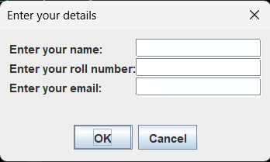

Question Display Module:

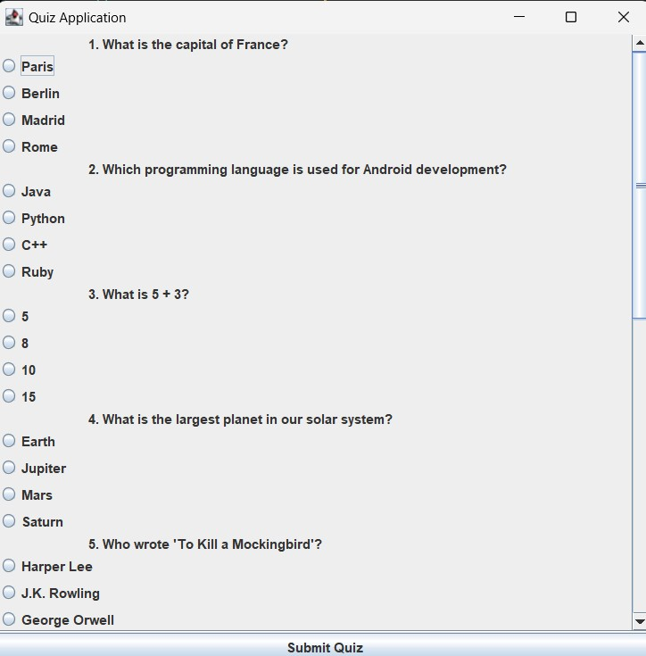

Answer Tracking Module:

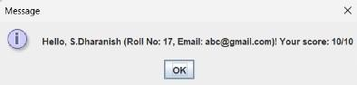

REFERENCES:

Books:
    - Head First Java by Kathy Sierra and Bert Bates
    - Java: The Complete Reference by Herbert Schildt
    - Effective Java by Joshua Bloch
    - Introduction to Java Programming and Data Structures by Y. Daniel Liang

Websites:
- Geeks for Geeks - Java Programming
  - Offers tutorials, examples, and data structure implementation for Java.
- W3Schools - Java
  - Beginner-friendly resource for learning Java syntax and concepts.
- Oracle Java Documentation
  - Official documentation for Java development, including Swing and JavaFX for GUI.
- JavaT Point - Java Swing Tutorial
  - Step-by-step guide to creating Java GUI applications.

